***Weather Forecast***

Postman

API: GET

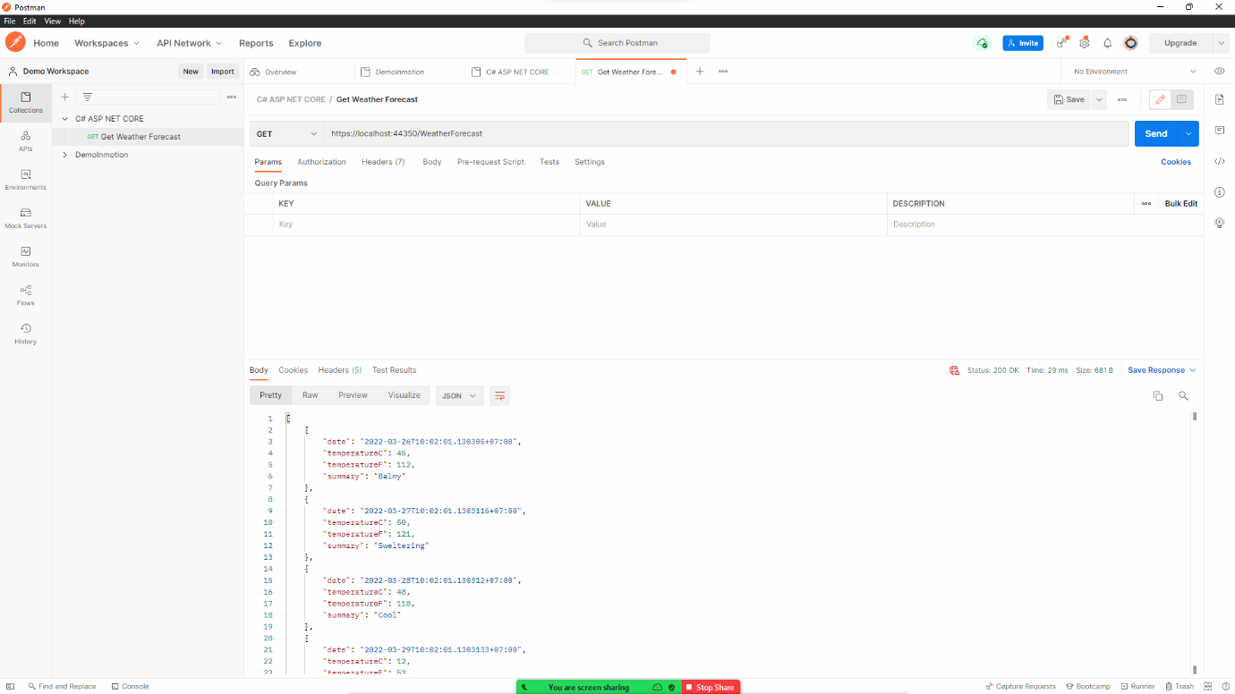URL: https://localhost:44350/WeatherForecast

Swagger

API: GET

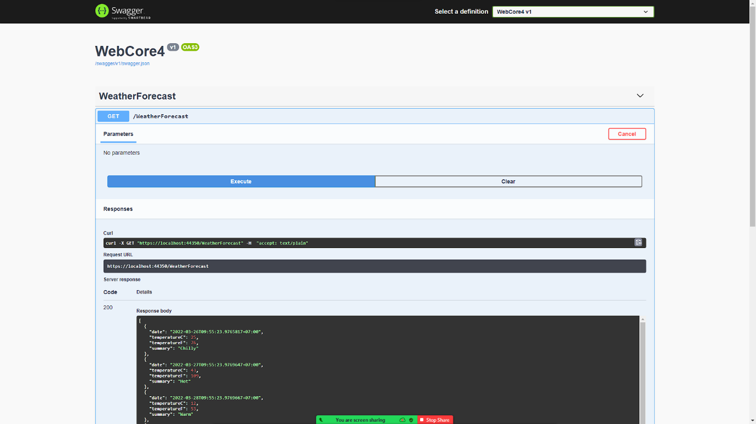URL: /WeatherForecast

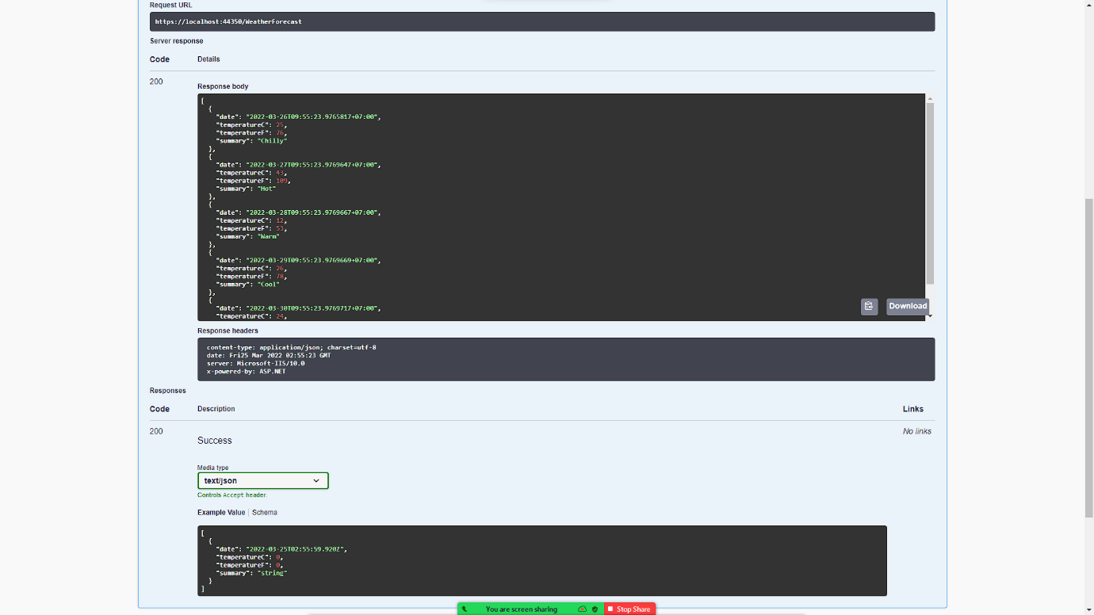

Web

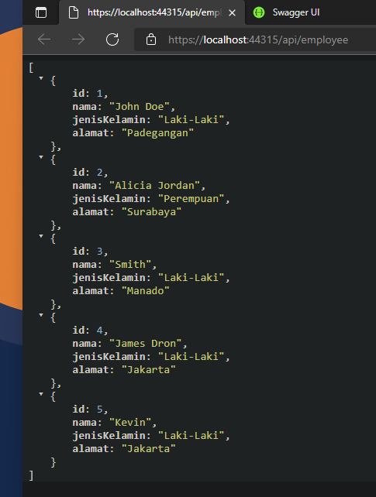URL: <https://localhost:44350/WeatherForecast>

***Employee***

Postman

API: GET

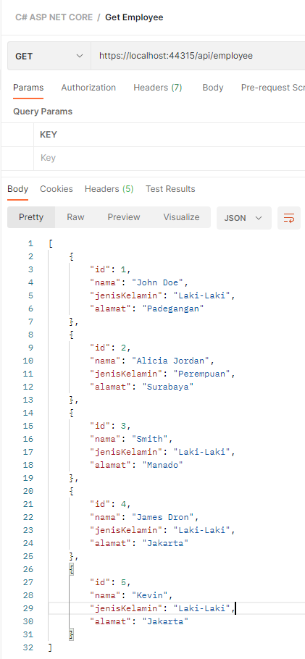URL: <http://localhost:44350/api/employee>

API: GET

Parameter: ID (ID = 2)

URL: <http://localhost:44350/api/employee/:id>

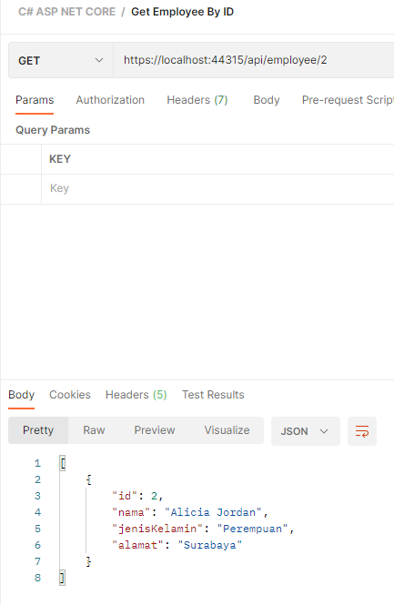

Swagger

API: GET

URL: <https://localhost:44350/swagger>

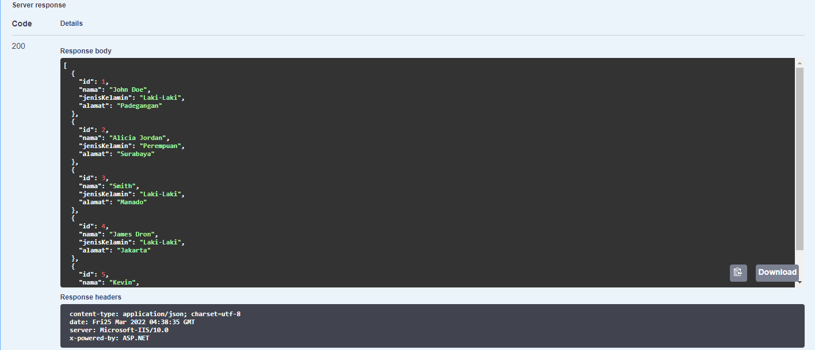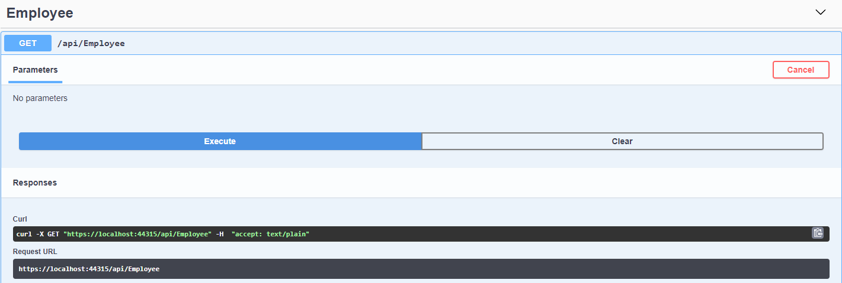

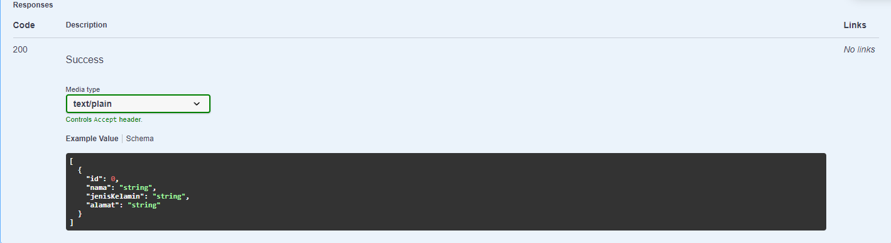

API: GET

Parameter: ID (ID = 1)

URL: <https://localhost:44350/swagger>

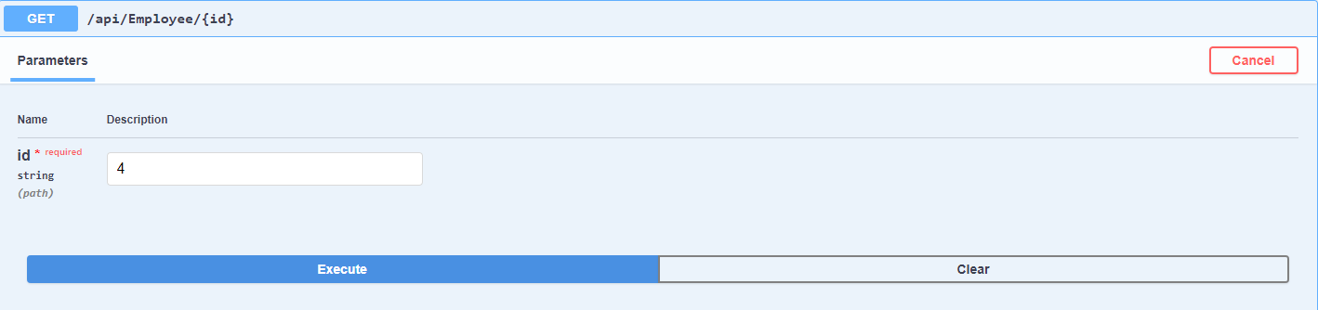

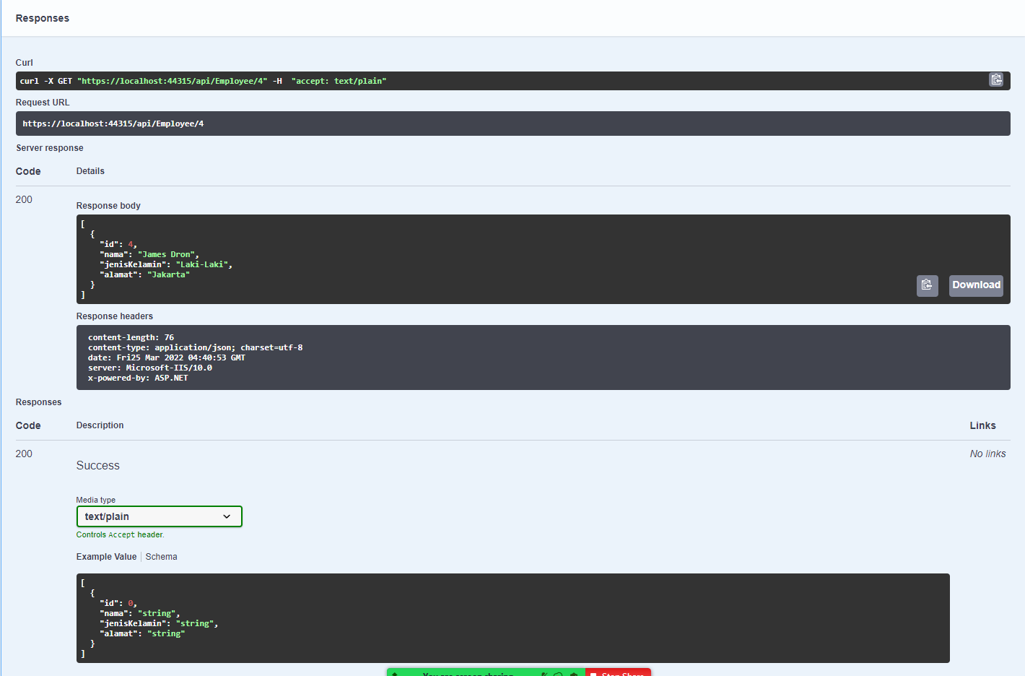

Web

URL: <https://localhost:44350/api/employee>

